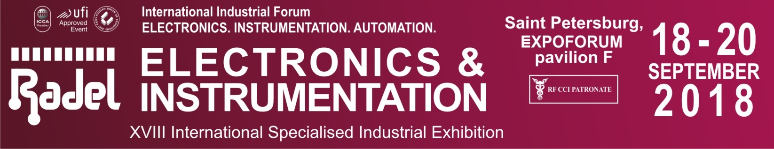
Press Badge Application Form
The editorial office of ______________________________________ plans to cover the RADEL exhibition. In this regard, we ask you to register the following employees for work at the exhibition from 18 to 20 September, 2018:

Full Name | Position | E-mail
1.

2

3

4

Mass Media Background

Mass Media Type: _______________________________________________________________

Specialization: _________________________________________________________________

Program’s Name (for TV and Radio): ______________________________________________

Address: ____________________________________________________________________

Phone: _______________________________________________________________________

http:__________________________________________________________________________

Estimated Publication Date: _____________________________________________________

To submit an interview with the Motor Show Director or visitors and honor guests, please indicate (person, date and time): ___________________________________________________________________________

Full name (Chief Editor / Program Manager):
__________________________________________________

- To register please return form to Julia Eliseeva - fax: +7(812) 777-04-07 or on e-mail: adv@farexpo.ru
- The number of journalists for print, radio and Internet media - maximum of 2 people, for television - 4

